# Lab: Document Object Model

Problems for in-class lab for the [“JavaScript Advanced” course @ SoftUni](https://softuni.bg/courses/javascript-advanced). Submit your solutions in the SoftUni judge system at <https://judge.softuni.bg/Contests/328/>.

## Sum Numbers

Write a JS function that **reads** two numbers from input fields in a **web page** and puts their **sum in another field** when the user **clicks** on a button.

### Input/Output

There will be no input/output, your program should instead **modify** the DOM of the given HTML document.

|  |
| --- |
| **Sample HTML** |
| <input type="text" id="num1" /> +  <input type="text" id="num2" /> =  <input type="text" id="sum" readonly="readonly" />  <input type="button" value="Calc" onclick="calc()" />  <script>  function calc() {  // TODO: sum = num1 + num2  }  </script> |

### Examples

### 

## Show More

Write a JS function that **expands** a hidden section of text when a link is **clicked**. The link should **disappear** as the rest of the text shows up.

### Input/Output

There will be no input/output, your program should instead **modify** the DOM of the given HTML document.

|  |
| --- |
| **Sample HTML** |
| Welcome to the "Show More Text Example".  <a href="#" id="more" onclick= "showText()">Read more …</a>  <span id="text" style= "display:none">Welcome to JavaScript and DOM.</span>  <script>  function showText() {  // TODO  }  </script> |

### Examples

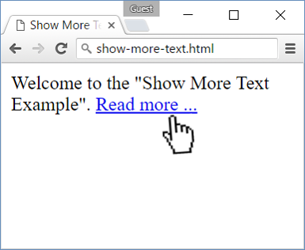 🡪 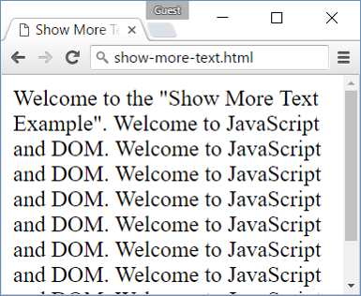

## Collect List Items

Write a JS function that scans a given **HTML list** and **appends** all collected list items’ text to a **text area** on the same page when the user **clicks** on a button.

### Input/Output

There will be no input/output, your program should instead **modify** the DOM of the given HTML document.

|  |
| --- |
| **Sample HTML** |
| <ul id="items">  <li>first item</li>  <li>second item</li>  <li>third item</li>  </ul>  <textarea id="result"></textarea>  <br>  <button onclick="extractText()">Extract Text</button>  <script>  function extractText() {  // TODO  }  </script> |

### Examples

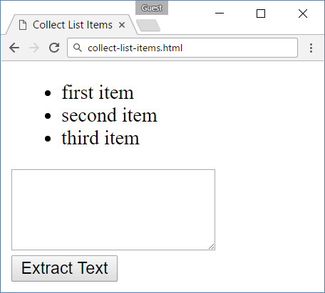 🡪 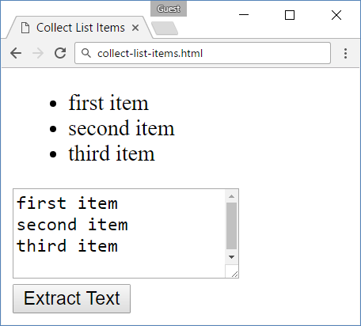

## Colorize Table

Write a JS function that **changes the color** of all **even** rows when the user **clicks** a button. Apply the color "**Teal**" to the target rows.

### Input/Output

There will be no input/output, your program should instead **modify** the DOM of the given HTML document.

|  |
| --- |
| **Sample HTML** |
| <table>  <tr><th>Name</th><th>Town</th></tr>  <tr><td>Eve</td><td>Sofia</td></tr>  <tr><td>Nick</td><td>Varna</td></tr>  <tr><td>Didi</td><td>Ruse</td></tr>  <tr><td>Tedy</td><td>Varna</td></tr>  </table>  <button onclick="colorize()">Colorize</button>  <script>  function colorize() {  // TODO  }  </script> |

### Examples

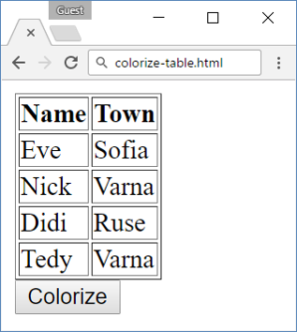 🡪 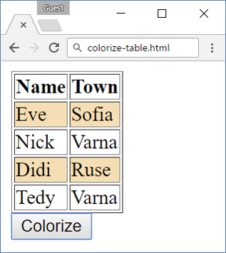

## Extract Parenthesis

Write a JS function that when **executed**, extracts all parenthesized text from a target paragraph by given element ID. The result is a string, joined by "; " (semicolon, space).

### Input

Your function will receive a **string parameter**, representing the target element ID, from which text must be extracted. The text should be extracted from the DOM.

### Output

**Return a string** with all matched text, separated by "; " (semicolon, space).

### Examples

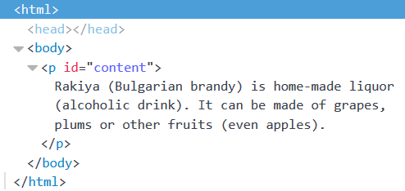

|  |
| --- |
| **Sample call** |
| let text = extract("content"); |
| **Result (stored in variable text)** |
| Bulgarian brandy; alcoholic drink; even apples |